**A8-2: Sorting**

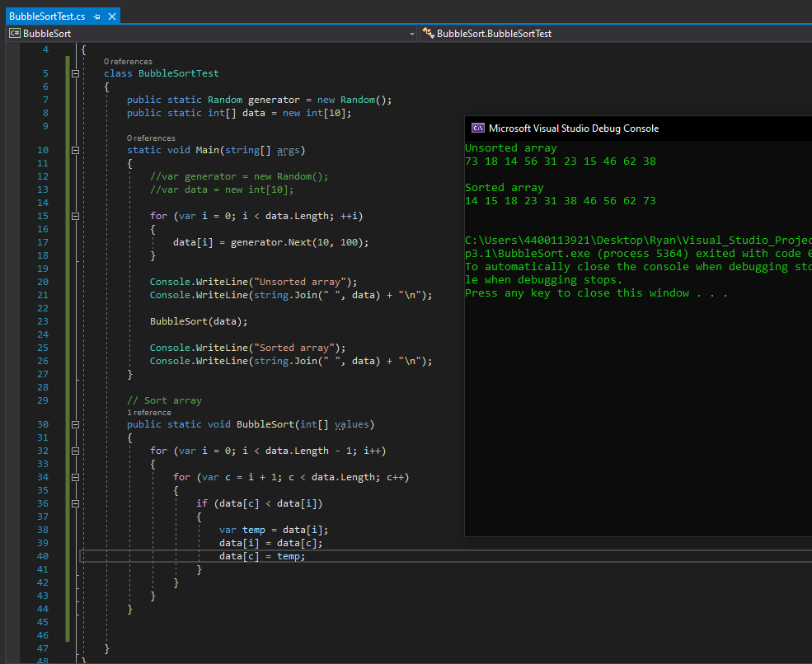

**Explain why bubble sort is an O(n2) algorithm:**

Bubble sort sorting algorithm has quadratic runtime complexity (O(n2) in Big O notation) because in worst case scenario, both loops, each going over the same list (***var I*** and ***var c***), in the above code with the ***BubbleSort***() method must run the maximum number of times. That is time increases by four as size doubles. So, plotting time vs. data size results in the sort of curve you get with a quadratic equation.